**C programming:**

#include <stdio.h>

void checkperfect(int sn){

int sum=0;

for( int i=1;i<sn;i++)

{

if(sn%i==0)

{

sum+=i;

}

}

if(sum==sn)

{

printf("perfect no.: %d\n",sn);

}

}

int main() {

int sn,en;

int sum=0;

printf("Enter the range:");

scanf("%d %d",&sn,&en);

for(int i=sn;i<en;i++)

{

checkperfect(i);

}

return 0;

}

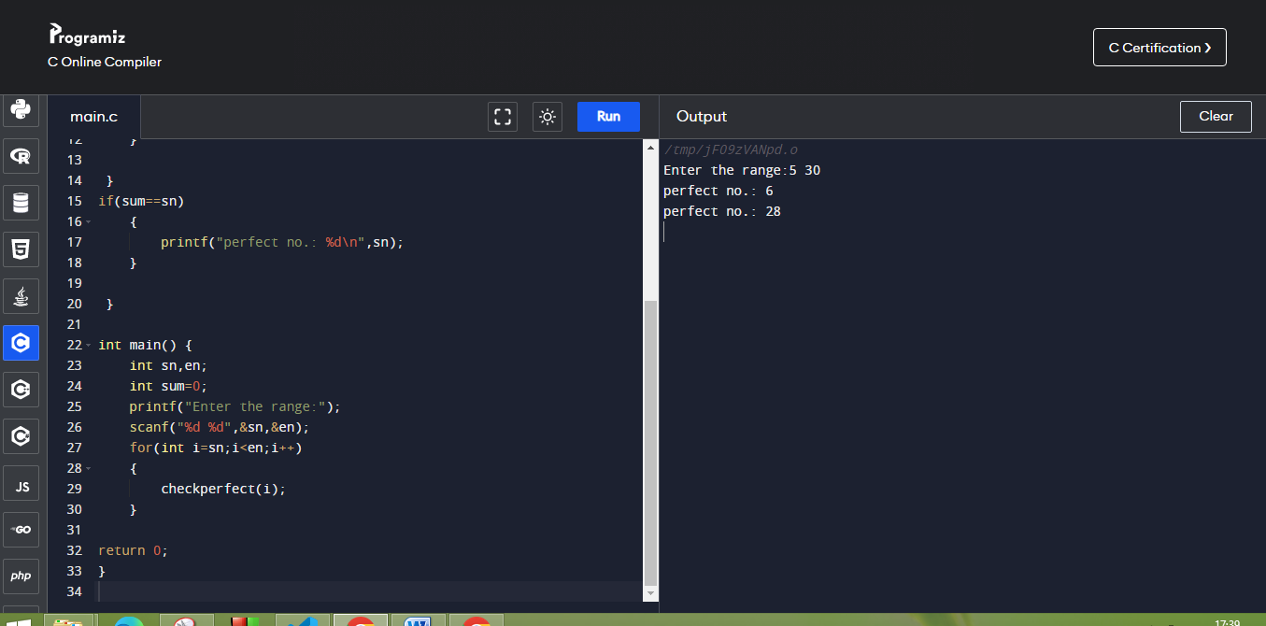

**Python:**

def checkperfect(sn,en):

for i in range (sn,en+1):

sum=0

for j in range (1,i):

if(i%j==0):

sum+=j

if(sum==i):

print("The perfect no.:"+str (i))

sn = int(input("Enter a starting range num:"))

en = int(input("Enter a ending range num:"))

checkperfect(sn,en)

